1.Create an android application that shows “welcome android” and run it on the emulator?

* Go to android studio
* Create new project
* Resources
* layouts

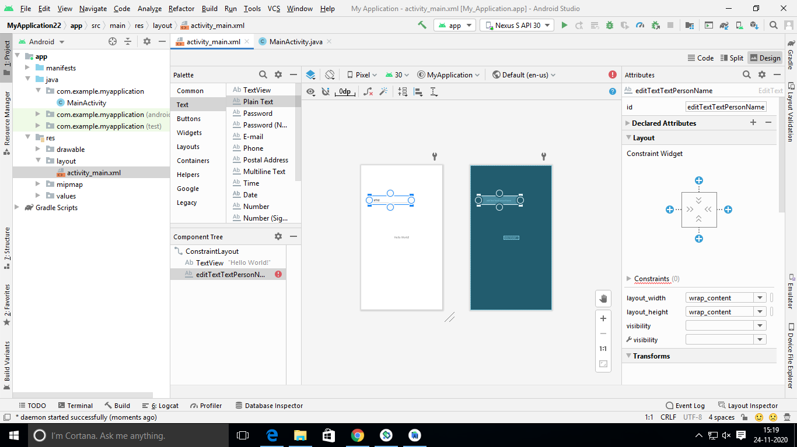

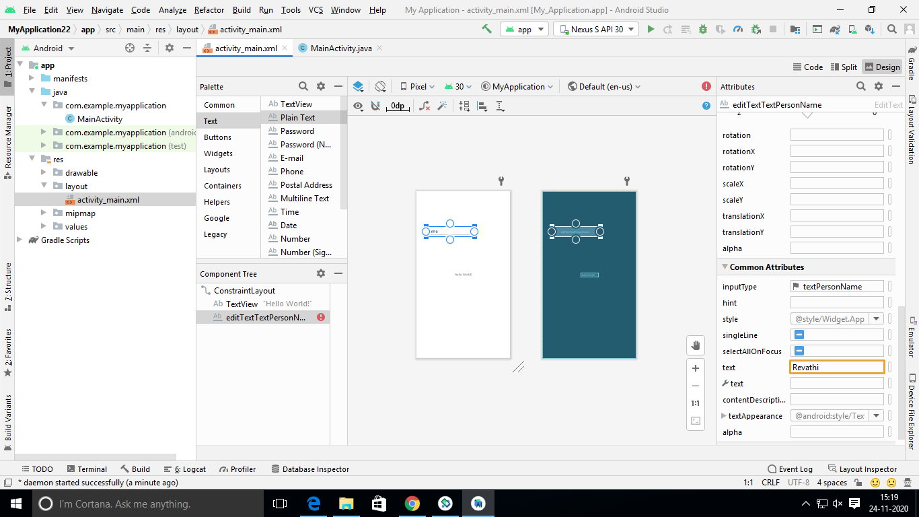

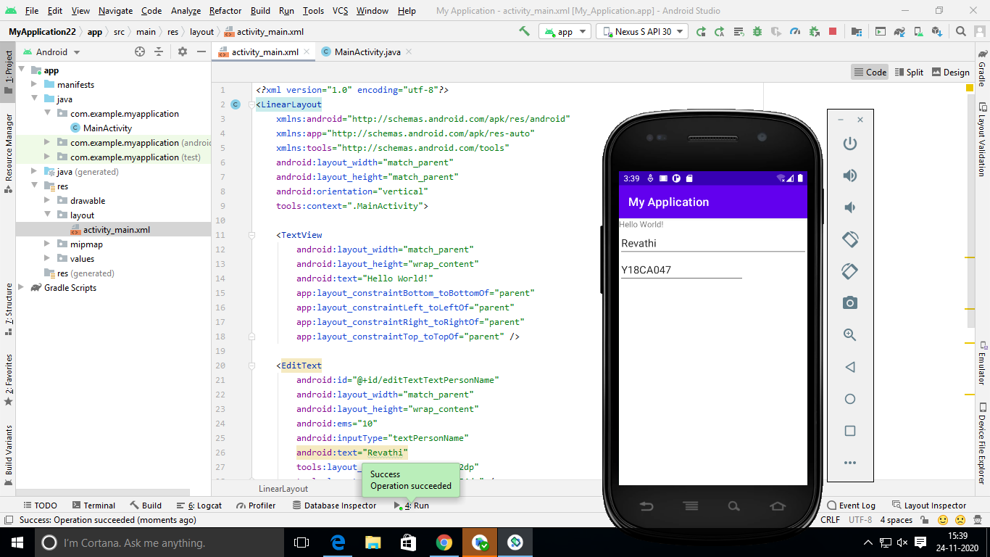

***Activity-main.xml***

*<?*xml version="1.0" encoding="utf-8"*?>*<linearLayout

xmlns:android="http://schemas.android.com/apk/res/android"  
 xmlns:app="http://schemas.android.com/apk/res-auto"  
 xmlns:tools="http://schemas.android.com/tools"  
 android:layout_width="match_parent"  
 android:layout_height="match_parent"  
 android:orientation="vertical"  
 tools:context=".MainActivity">  
  
 <TextView  
 android:layout_width="match_parent"  
 android:layout_height="wrap_content"  
 android:text="Hello World!"  
 app:layout_constraintBottom_toBottomOf="parent"  
 app:layout_constraintLeft_toLeftOf="parent"  
 app:layout_constraintRight_toRightOf="parent"  
 app:layout_constraintTop_toTopOf="parent" />  
  
 <EditText  
 android:id="@+id/editTextTextPersonName"  
 android:layout_width="match_parent"  
 android:layout_height="wrap_content"  
 android:ems="10"  
 android:inputType="textPersonName"  
 android:text="abcd"  
 tools:layout_editor_absoluteX="42dp"  
 tools:layout_editor_absoluteY="154dp" />

<EditText  
 android:id="@+id/editTextTextPersonName2"  
 android:layout_width="wrap_content"  
 android:layout_height="wrap_content"  
 android:ems="10"  
 android:inputType="textPersonName"  
 android:text="Y18CA000"  
 tools:layout_editor_absoluteX="66dp"  
 tools:layout_editor_absoluteY="313dp" />

</LinearLayout>